**Saaili Amborkar**

**EMPLOYEE TABLE**

**1)CREATING TABLE**

CREATE TABLE employees (

emp_id INT PRIMARY KEY,

name VARCHAR(100) NOT NULL,

department VARCHAR(50),

salary DOUBLE,

join_date DATE

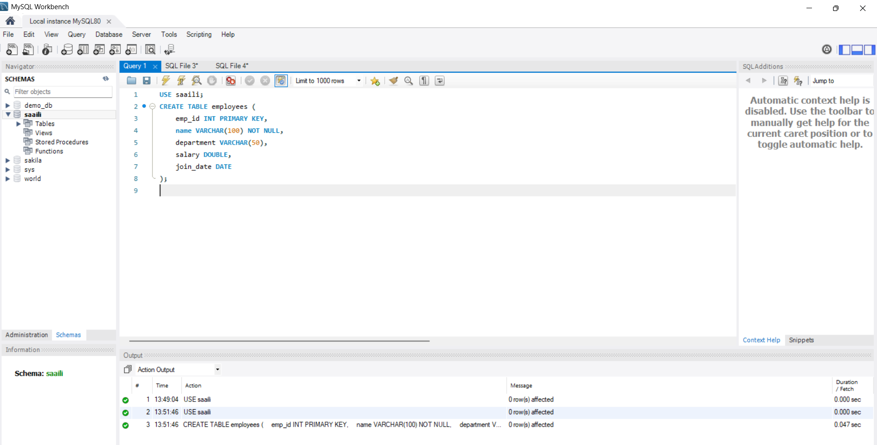

**2)INERT QUERY**

INSERT INTO employees (emp_id, name, department, salary, join_date) VALUES

(101, 'John Doe', 'HR', 45000, '2021-06-15'),

(102, 'Jane Smith', 'IT', 75000, '2020-01-10'),

(103, 'Alice Johnson', 'Finance', 60000, '2019-08-23'),

(104, 'Bob Brown', 'IT', 80000, '2022-03-01'),

(105, 'Eve Davis', 'Marketing', 55000, '2021-11-05');

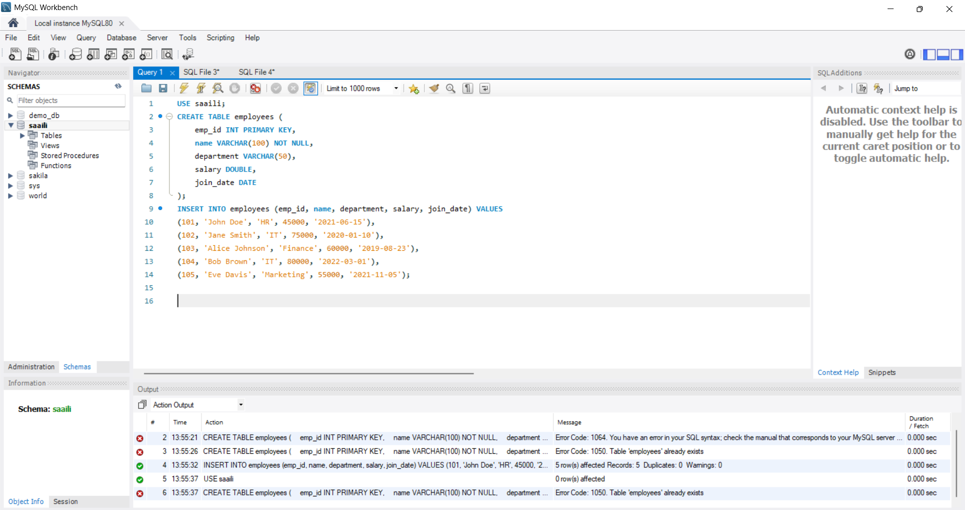

**3) SELECT QUERY**

* SELECT * FROM employees;

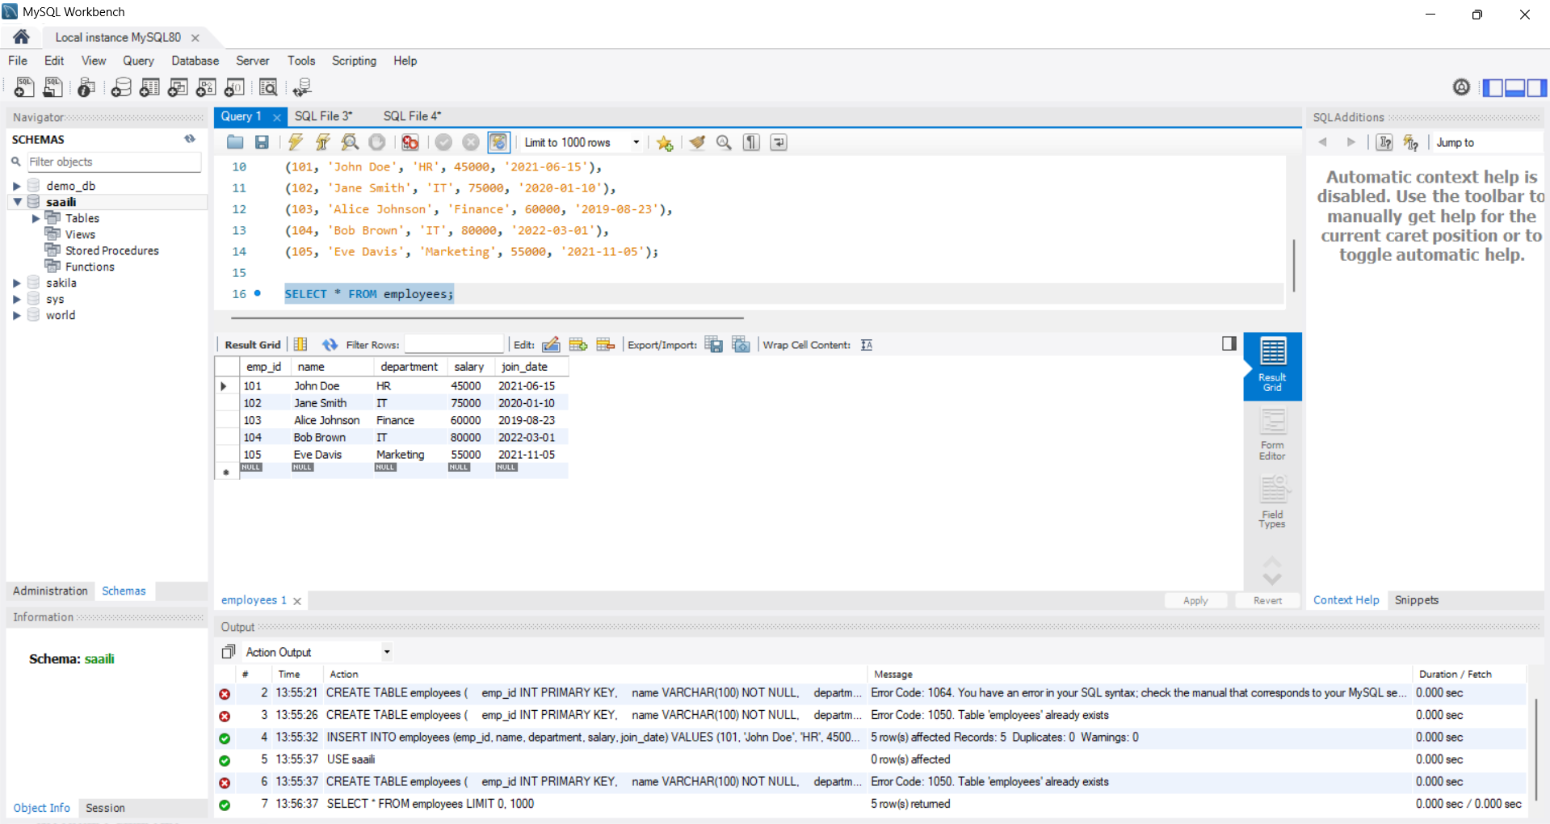

* SELECT name, department FROM employees;

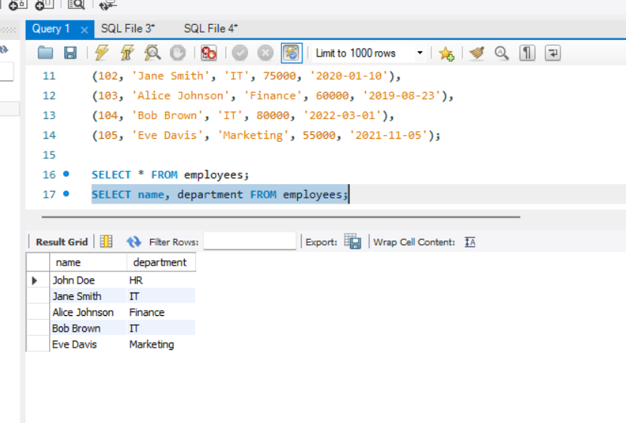

* SELECT * FROM employees WHERE department = 'IT';

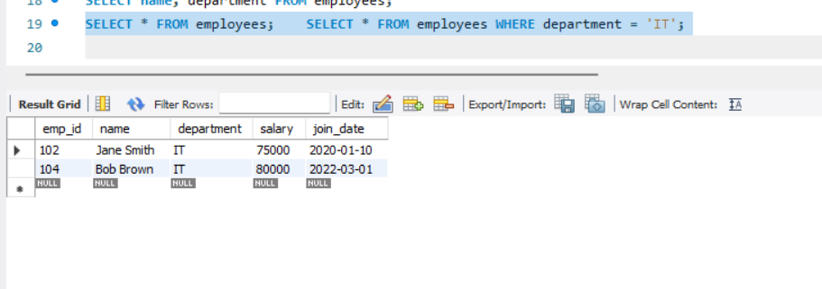

**4) AND, IN BETWEEN & LIKE**

* SELECT * FROM employees WHERE department = 'IT' AND salary > 75000;

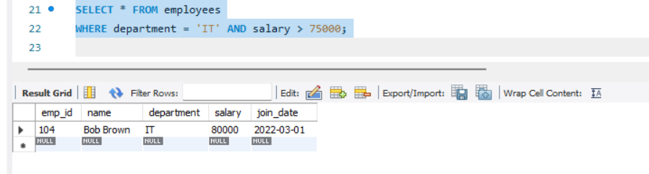

* SELECT * FROM employees WHERE department IN ('IT', 'Finance');

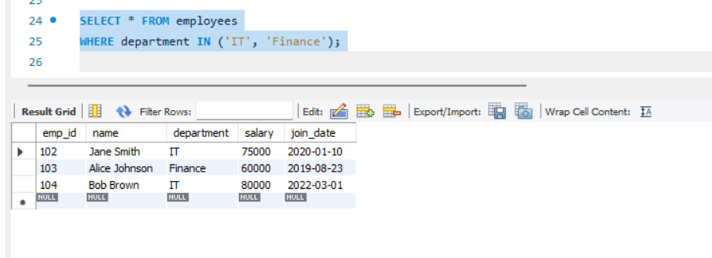

* SELECT * FROM employees WHERE salary BETWEEN 50000 AND 70000;

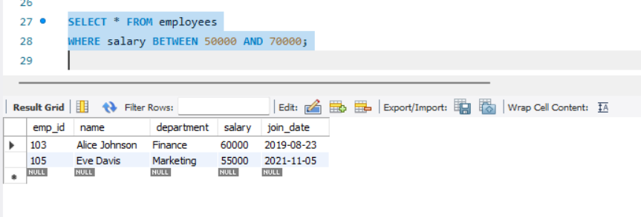

* SELECT * FROM employees WHERE name LIKE 'J%'; -- Names starting with J

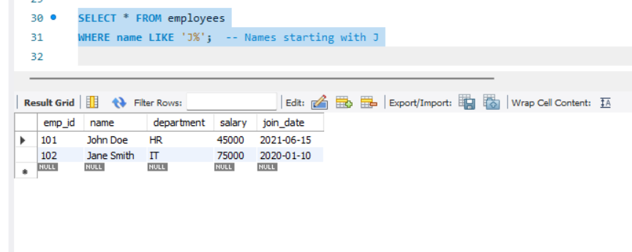

**5)CLAUSE -ORDER BY, WHERE, HAVING**

SELECT * FROM employees

ORDER BY salary DESC;

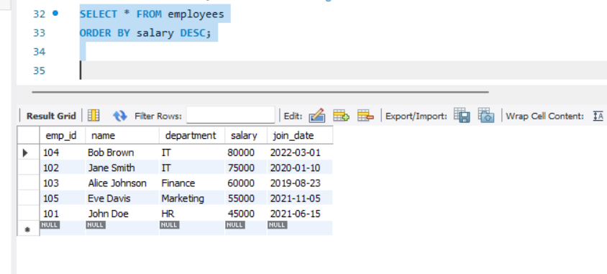

**6)UPDATE QUERY**

* UPDATE employees

SET salary = 82000

WHERE emp_id = 104;

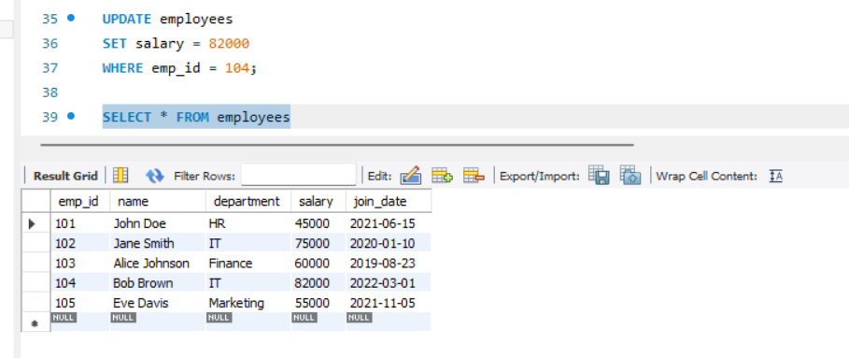

* DELETE FROM employees

WHERE emp_id = 105;

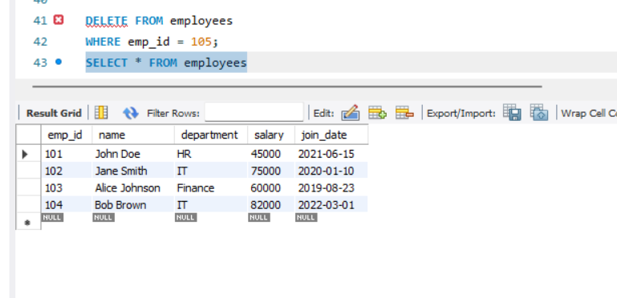

* SELECT department, AVG(salary) AS avg_salary

FROM employees

GROUP BY department;

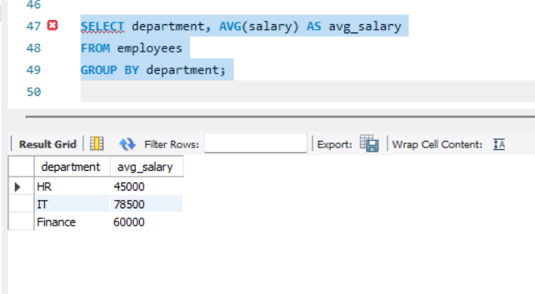

* SELECT department, COUNT(*) AS emp_count

FROM employees

GROUP BY department

HAVING COUNT(*) > 1;

